EXP – 6

clear; clc; close all;

Fs = 8000;
fc = 1500;
wc = fc / (Fs/2); % Normalized cutoff frequency
N = 50; % Filter order

% Window Functions
w_rect = rectwin(N+1);
w_hamm = hamming(N+1);
w_hann = hann(N+1);
w_black = blackman(N+1);

% FIR Low-Pass Filter Design using fir1
b_rect = fir1(N, wc, w_rect);
b_hamm = fir1(N, wc, w_hamm);
b_hann = fir1(N, wc, w_hann);
b_black = fir1(N, wc, w_black);

% Frequency Response Calculation
[H_rect, f] = freqz(b_rect, 1, 1024, Fs);
[H_hamm, ~] = freqz(b_hamm, 1, 1024, Fs);
[H_hann, ~] = freqz(b_hann, 1, 1024, Fs);
[H_black, ~] = freqz(b_black, 1, 1024, Fs);

% Display Numerical Outputs
fprintf('=== EXPERIMENT 4: FIR WINDOWING TECHNIQUES ===\n\n');
fprintf('Filter Order (N): %d\n', N);
fprintf('Cutoff Frequency: %d Hz\n\n', fc);

fprintf('--- RECTANGULAR WINDOW COEFFICIENTS (First 5) ---\n');
disp(b_rect(1:5));

fprintf('--- HAMMING WINDOW COEFFICIENTS (First 5) ---\n');
disp(b_hamm(1:5));

fprintf('--- HANN WINDOW COEFFICIENTS (First 5) ---\n');
disp(b_hann(1:5));

fprintf('--- BLACKMAN WINDOW COEFFICIENTS (First 5) ---\n');
disp(b_black(1:5));

% Convert Magnitude to dB safely
mag_rect = 20*log10(max(abs(H_rect), 1e-10));
mag_hamm = 20*log10(max(abs(H_hamm), 1e-10));
mag_hann = 20*log10(max(abs(H_hann), 1e-10));
mag_black = 20*log10(max(abs(H_black), 1e-10));

% Plot Frequency Responses
figure('Name', 'FIR Windowing Techniques Comparison');

subplot(2,1,1);

plot(f, mag_rect, 'k', 'LineWidth', 1.2);
hold on;
plot(f, mag_hamm, 'b', 'LineWidth', 1.5);
plot(f, mag_hann, 'g', 'LineWidth', 1.5);
plot(f, mag_black, 'r', 'LineWidth', 1.5);

grid on;
legend('Rectangular', 'Hamming', 'Hann', 'Blackman', ...
'Location', 'best');
title('FIR Low-Pass Filter Magnitude Response (N = 50)');
xlabel('Frequency (Hz)');
ylabel('Magnitude (dB)');
xlim([0 Fs/2]);
ylim([-100 10]);

% Phase Response using Hamming Window
subplot(2,1,2);

plot(f, unwrap(angle(H_hamm))*180/pi, ...
'b', 'LineWidth', 1.5);

grid on;
title('Phase Response (Hamming Window)');
xlabel('Frequency (Hz)');
ylabel('Phase (degrees)');
xlim([0 Fs/2]);

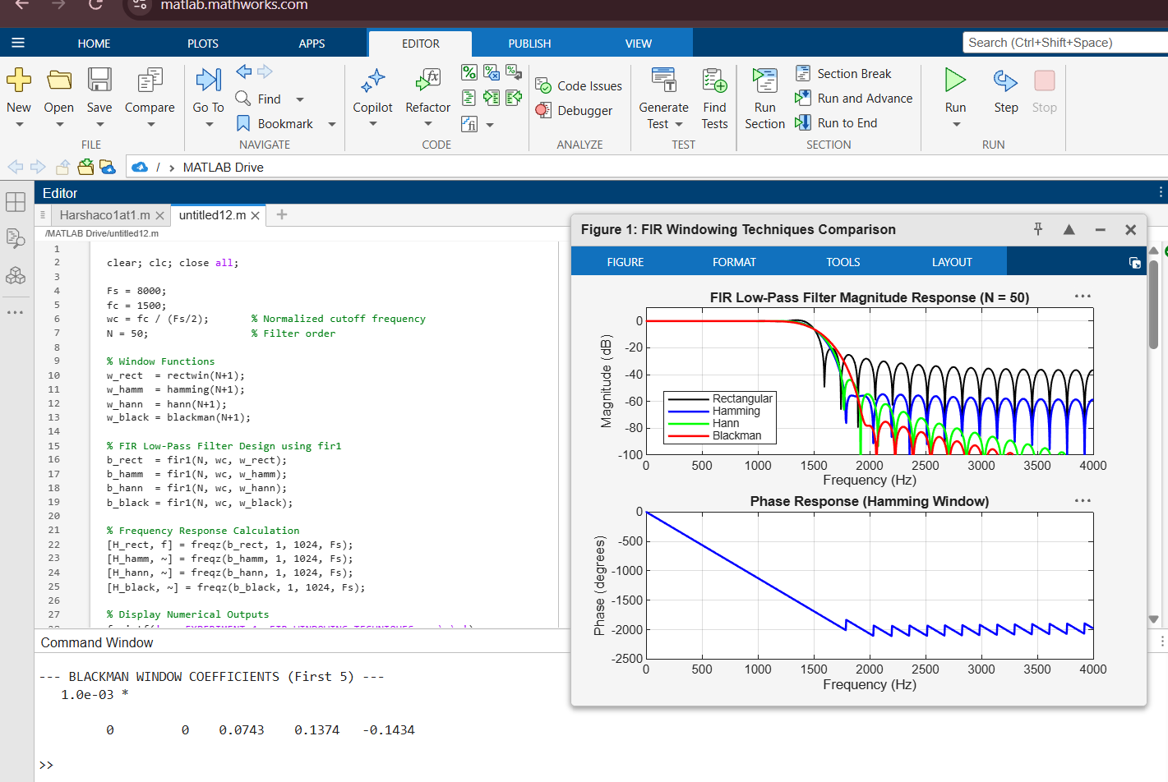

EXP -7

clear; clc; close all;

Fs = 10000;
fp = 1500;
fs = 2000;
N = 40; % Filter order

% 1. Parks-McClellan (Equiripple) Design
f_bands = [0 fp fs Fs/2] / (Fs/2);
a_bands = [1 1 0 0];

b_pm = firpm(N, f_bands, a_bands);

% 2. Frequency-Sampling Design
% Frequency points and desired amplitudes
f_grid = [0 fp fs Fs/2] / (Fs/2);
a_grid = [1 1 0 0];

b_fs = fir2(N, f_grid, a_grid);

% Display Numerical Outputs
fprintf('=== EXPERIMENT 5: PARKS-MCCLELLAN vs FREQUENCY SAMPLING ===\n\n');
fprintf('Filter Order (N): %d\n', N);
fprintf('Passband Edge: %d Hz\n', fp);
fprintf('Stopband Edge: %d Hz\n\n', fs);

fprintf('--- PARKS-MCCLELLAN COEFFICIENTS (First 10) ---\n');
disp(b_pm(1:10));

fprintf('--- FREQUENCY-SAMPLING COEFFICIENTS (First 10) ---\n');
disp(b_fs(1:10));

% Frequency Response Calculation
[H_pm, f] = freqz(b_pm, 1, 2048, Fs);
[H_fs, ~] = freqz(b_fs, 1, 2048, Fs);

% Convert Magnitude to dB safely
mag_pm = 20*log10(max(abs(H_pm), 1e-10));
mag_fs = 20*log10(max(abs(H_fs), 1e-10));

% Plotting
figure('Name', 'Parks-McClellan vs Frequency-Sampling');

% Magnitude Response
subplot(2,1,1);

plot(f, mag_pm, 'b', 'LineWidth', 1.5);
hold on;
plot(f, mag_fs, 'r--', 'LineWidth', 1.5);

grid on;
legend('Parks-McClellan (Equiripple)', ...
'Frequency-Sampling', 'Location', 'best');

title(['FIR Filter Magnitude Response Comparison (Order N = ', ...
num2str(N), ')']);

xlabel('Frequency (Hz)');
ylabel('Magnitude (dB)');
xlim([0 Fs/2]);
ylim([-80 10]);

% Phase Response
subplot(2,1,2);

plot(f, unwrap(angle(H_pm))*180/pi, ...
'b', 'LineWidth', 1.5);
hold on;
plot(f, unwrap(angle(H_fs))*180/pi, ...
'r--', 'LineWidth', 1.5);

grid on;
legend('Parks-McClellan', 'Frequency-Sampling', ...
'Location', 'best');

title('Phase Response Comparison');
xlabel('Frequency (Hz)');
ylabel('Phase (degrees)');
xlim([0 Fs/2]);

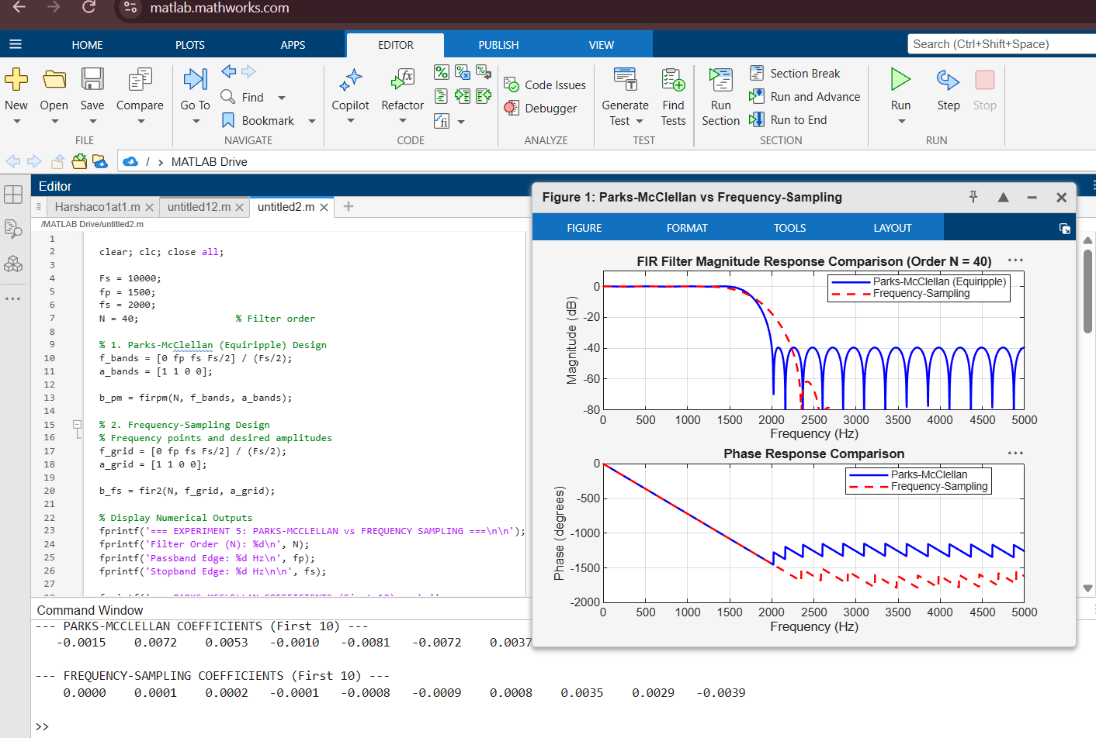

EXP -8

clc; clear; close all;

%% FIR FILTER PARAMETERS
b = [0.0625 0.2500 0.3750 0.2500 0.0625];
Fs = 1000;
N = 128;

x = [1 zeros(1,N-1)];
n = 0:N-1;

%% 1. DIRECT REALIZATION
yd = filter(b,1,x);

%% 2. CASCADE REALIZATION
z = roots(b);
g = b(1);

% Group conjugate zeros into real first/second-order sections
yc = g*x;
used = false(length(z),1);
tol = 1e-8;

for k = 1:length(z)
if used(k)
continue;
end

if abs(imag(z(k))) < tol
% Real zero: first-order section
section = [1 -real(z(k))];
used(k) = true;
else
% Find the complex-conjugate zero
candidates = find(~used);
candidates(candidates == k) = [];

[~,idx] = min(abs(z(candidates)-conj(z(k))));
kc = candidates(idx);

% Real second-order section
section = real(poly([z(k); z(kc)]));
used(k) = true;
used(kc) = true;
end

yc = filter(section,1,yc);
end

yc = real(yc);

%% 3. SYMMETRY AND LINEAR PHASE
symErr = max(abs(b-fliplr(b)));
D = (length(b)-1)/2;

if symErr < 1e-12
symmetry = 'Symmetric';
else
symmetry = 'Not Symmetric';
end

%% 4. FREQUENCY, PHASE AND GROUP DELAY
[H,w] = freqz(b,1,1024);
phase = unwrap(angle(H));
[gd,wgd] = grpdelay(b,1,1024);

%% 5. NUMERICAL COMPARISON
err = max(abs(yd-yc));
dev = err/max(max(abs(yd)),eps)*100;

%% DISPLAY RESULTS
fprintf('\n============================================\n');
fprintf(' FIR FILTER REALIZATION RESULTS\n');
fprintf('============================================\n');

fprintf('\nFIR Coefficients:\n');
disp(b);

fprintf('Sampling Frequency = %d Hz\n',Fs);
fprintf('Number of Samples = %d\n',N);
fprintf('Coefficient Symmetry = %s\n',symmetry);
fprintf('Symmetry Error = %.3e\n',symErr);
fprintf('Group Delay = %.2f samples\n',D);

fprintf('\nMaximum Error = %.3e\n',err);
fprintf('Percentage Deviation = %.3e %%\n',dev);

%% FIRST 10 IMPULSE RESPONSE VALUES
fprintf('\n============================================\n');
fprintf(' FIRST 10 IMPULSE RESPONSE VALUES\n');
fprintf('============================================\n');

fprintf('%4s %14s %14s\n','n','Direct','Cascade');

for k = 1:10
fprintf('%4d %14.6f %14.6f\n',n(k),yd(k),yc(k));
end

%% CASCADE ZEROS
fprintf('\n============================================\n');
fprintf(' CASCADE REALIZATION ZEROS\n');
fprintf('============================================\n');

disp(z);

%% OUTPUT PARAMETER TABLE
Parameter = {
'Direct realization output'
'Cascade realization output'
'Impulse response'
'Phase response'
'Comparison of realizations'
};

Observation = {
'Direct FIR filtering'
'Cascade of first/second-order sections'
'Equal to FIR coefficient sequence'
'Linear phase'
'Equivalent transfer-function behavior'
};

Value = {
sprintf('[%.4f %.4f %.4f %.4f %.4f]',yd(1:5))
sprintf('[%.4f %.4f %.4f %.4f %.4f]',yc(1:5))
sprintf('[%.4f %.4f %.4f %.4f %.4f]',yd(1:5))
sprintf('Group delay = %.2f samples',D)
sprintf('Max error = %.3e; Deviation = %.3e %%',err,dev)
};

Unit_Note = {
'Amplitude'
'Amplitude'
'h[n]'
'Samples'
'Numerical precision'
};

Output_Table = table(Parameter,Observation,Value,Unit_Note);

fprintf('\n============================================\n');
fprintf(' OUTPUT PARAMETER TABLE\n');
fprintf('============================================\n');

disp(Output_Table);

%% GRAPH 1: DIRECT VS CASCADE IMPULSE RESPONSE
figure('Name','Direct vs Cascade Impulse Response');

stem(n,yd,'b','filled');
hold on;
stem(n,yc,'r--');
grid on;

xlabel('Sample n');
ylabel('Amplitude');
title('Direct and Cascade FIR Impulse Responses');
legend('Direct Realization','Cascade Realization');

%% GRAPH 2: MAGNITUDE RESPONSE
figure('Name','FIR Magnitude Response');

plot(w/pi,abs(H),'LineWidth',1.5);
grid on;

xlabel('Normalized Frequency (\times\pi rad/sample)');
ylabel('|H(e^{j\omega})|');
title('FIR Magnitude Response');
xlim([0 1]);

%% GRAPH 3: PHASE RESPONSE
figure('Name','FIR Phase Response');

plot(w/pi,phase,'LineWidth',1.5);
grid on;

xlabel('Normalized Frequency (\times\pi rad/sample)');
ylabel('Phase (radians)');
title('Unwrapped Phase Response');
xlim([0 1]);

%% GRAPH 4: GROUP DELAY
figure('Name','FIR Group Delay');

plot(wgd/pi,gd,'LineWidth',1.5);
grid on;

xlabel('Normalized Frequency (\times\pi rad/sample)');
ylabel('Group Delay (samples)');
title('Group Delay');
xlim([0 1]);

%% GRAPH 5: NUMERICAL ERROR
figure('Name','Direct vs Cascade Numerical Error');

plot(n,abs(yd-yc),'LineWidth',1.5);
grid on;

xlabel('Sample n');
ylabel('Absolute Error');
title('Direct vs Cascade Numerical Error');

%% FINAL RESULT
fprintf('\n============================================\n');
fprintf(' FINAL RESULT\n');
fprintf('============================================\n');

fprintf('1. FIR filter realized using Direct structure.\n');
fprintf('2. FIR filter realized using Cascade structure.\n');
fprintf('3. Coefficients are %s.\n',symmetry);
fprintf('4. Linear-phase group delay = %.2f samples.\n',D);
fprintf('5. Maximum realization error = %.3e.\n',err);
fprintf('6. Percentage deviation = %.3e %%.\n',dev);
fprintf('7. Direct and Cascade responses are equivalent.\n');

